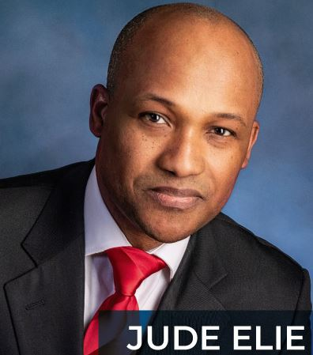
Jude Elie, Eng./Urbanist/MSCE, EMBA, Ph.D.
Destined to Lead Haiti
A Talented Negotiator- Straight as an Arrow, His Word is Our Command
Builder, Leader, Collaborator;
Honest & Inspired.
Untouched by fear, greed or crime.
Haitian Presidential Candidate

Jude Elie emanates from a prominent Haitian family who are all historically involved and dedicated to the betterment of their country. Jude vowed to work and improve the lives and conditions of his home country- and return to work on economic development. He feels there should be investment in the agricultural sector in Haiti, housing, and education.

Jude is a graduate of America’s second oldest engineering school, New York’s Polytechnic Institute of New York with a Masters in Science. He also enjoys an undergraduate degree in engineering from Haiti G.O.C. University, and has completed a graduate engineering course in Florida’s (F.A.U.), and an Executive MBA (Masters in Business Administration) from the State university of New York. Also, a PhD from Sorbon University, France.

With the mind of a humanity-centric engineer who always completed his mission, Jude has spent his life learning, designing, building, collaborating, supporting, and advocating for humanity. His interests include infrastructure, housing, and workforce development, with a deep focus on community. Jude is a hard-working individual who demonstrates strength, honesty, good judgment, Jude is a dedicated, hardworking, and industrious individual who demonstrates strength, honesty, solid good judgment are his assets

Most recently Jude has worked with the New York City Housing Authority (NYCHA) as an administrative project manager, with additional engineering contributions to the NY Department of Transportation, the New York City Transit/MTA, the Long Island Railroad/MTA, ChevronTexaco, and the Peace Corp in Haiti. Jude has carefully evolved his emerging life, story and career for the opportunity he has long planned for – and which has finally been presented to him: the opportunity to run for the office of President – and regeneration - of his beloved Haiti.

Jude’s is a savvy, strong, meticulous and globally backed ‘clean outsider’; someone with no vested interests except for making Haiti the greatest country it can be through pragmatic inclusive leadership. He brings the desire to unite the Haitian diaspora from all areas of the world- back to Haiti- to rebuild Haiti together to enjoy freedom and prosperity in Haiti.

In addition to his impressive education, Jude has developed world-class human and project management, and operational excellence skills that only the military, a government or a conglomerate could teach. He initiated his diversified engineering, project management and contract administration career with Haiti-based TECINA SA in 1994 as a Project Engineer. TECINA is a well-recognized construction firm in Haiti’s largest city specializing in architecture, public works, and building both custom and prefab homes. Once comfortable with knowledge gained, he then accepted a 7-year position with Chevron/Texaco, Haiti in 1997, first as a project coordinator, and thereafter advanced to the role of HES (Health, Environment, Safety) Manager for all of Haiti’s operations. His final advancement during this period still had him serving TexacoChevron, but also other companies, across Haiti, St. Maarten and the greater French Caribbean, as the Operations Excellence (OE) manager for Prologic until 2005.

During this 2004-2005 period, with his future Presidential aspirations in mind, Jude began developing extensive relationships with various Private and NGO agencies serving the region, such as USAID, MINUSTAH and Peace Corps. For several years he worked directly with the Peace Corps, project managing the renewal of their Haitian headquarters.

Over the last 15 years, in addition to ongoing engineering and management contributions to the City and State of New York, Jude and his schedulers have also managed to find the time for him to participate in various philanthropic organizations. This commitment reflects his belief that learning, sharing knowledge, and volunteering aid in the enrichment of both society and self.

After Haiti’s devastating earthquake of 2010, Jude assessed his optimal potential contribution to Haiti and organized Urban Disaster Resilience Forum, promoting Global Solidarity for Capacity Building of Local Governments and Operators in Disaster Vulnerable Regions for Urban Resilience Haiti: Challenges of Metropolitan Recovery & Sustainable Development - an international workshop with global experts to lend their expertise and advice to renewing Haiti’s water system.

Jude is also currently the president of Haitian Salesians of Don Bosco Past Pupils Worldwide; and a member of ASCE (American Society of Civil Engineering), NSBE (National Society of Black engineers), NASTT (North American Society for Trenchless Technology), W-SMART (Water Security Management Assessment Research and Technology), and Rotary Club International.

Over the past five years, Jude’s passion for Haiti began to inspire outreach from various of her political parties. This growing outreach to Jude reflects the appreciation of both his status as a non-corrupt outsider, but also, his long-lived priority to serve the people of Haiti and to bring back the country’s pride. Jude is always seeking both effective and mutually respectful team-based relationships with those whose values and mission are aligned.

As for his evolving diplomatic platform, Jude clearly recognizes that Haiti and her people need first class healthcare, education, infrastructure, clean potable water, reforestation and the evolution of fully sustainable Haitian-powered industries that can find a worthy role in the global economy. All Haitians – not just the President - need first class security.

Jude is ready to lead the task of regenerating Haiti – and giving all Haitians the quality of life, abundance, safety and opportunity that they should have enjoyed with their hard-won freedom of 1804. This will be a challenging task by all standards – particularly post the recent assassination of the sitting President. But a fresh start is completely possible, with an honest, capable and tenacious leader and team player like Jude Elie.

